**Web Portal Information**

Second Story provides safe havens and opportunities to grow and thrive for youth experiencing homelessness and youth and families in crisis. The Community Based Services Program provides safe havens and opportunities to grow and thrive for children, youth, and families. We work throughout the DMV area, and our programs are broad in scope, yet each of them shares a core goal: to offer safety and opportunities at critical moments to youth in crisis. We started operating our first program in 1972 for runaway youth and youth experiencing homelessness and have grown to meet the needs of children in our community ever since. We have served tens of thousands of young people since our inception. Among the COVID-19 pandemic, our program has grown to adjust changes to serve our community during public health crises better.

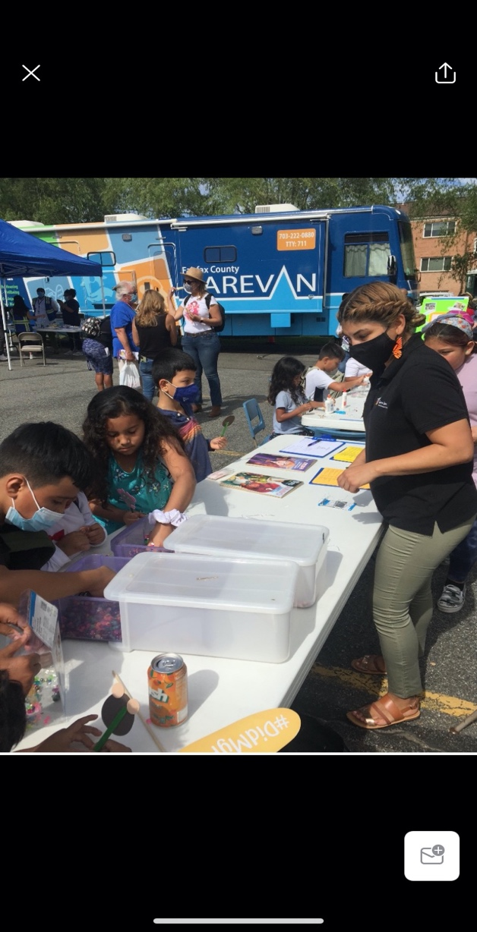Our collaboration with the Stronger 2 Project is to distribute medical resources to our communities. Our mission is to enhance equitable community response to COVID-19. Our program is open to all children, youth, and families for participating in Health Literacy classes, access to health fairs, and an invitation to vaccine clinics hosted by our Community-Based Service team. Second Story aims to reduce the language barrier and inform accurate information in our community. Second Story is dedicated to ensuring access to the COVID-19 vaccine, COVID-19 testing’s location, and promoting additional resources from the Health Department to serve our community. Our objective is to create an impact to help serve families on navigating the ongoing pandemic to assist with personal endeavors and provide a sense of security.

Vaccine Clinic in Culmore

Community Fair in Springfield

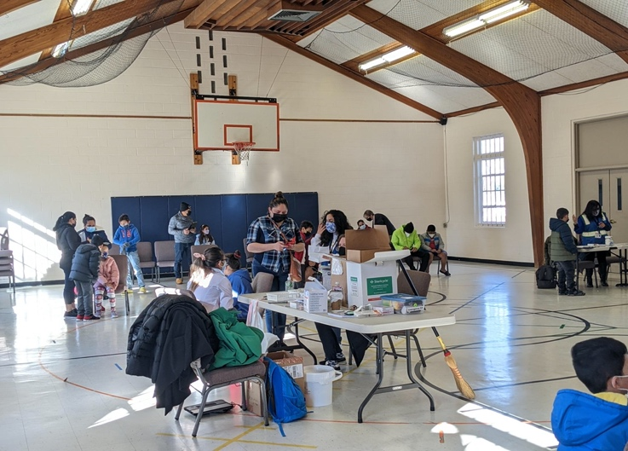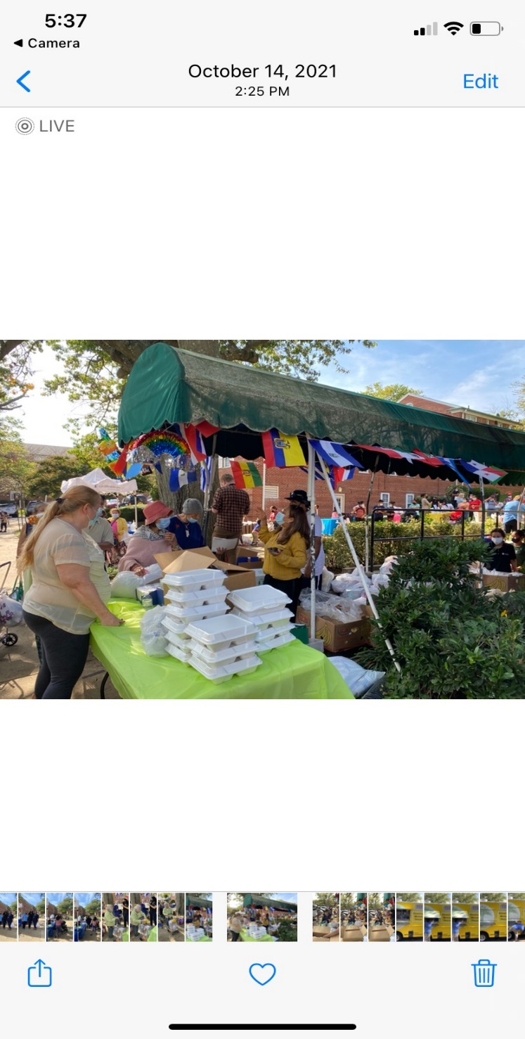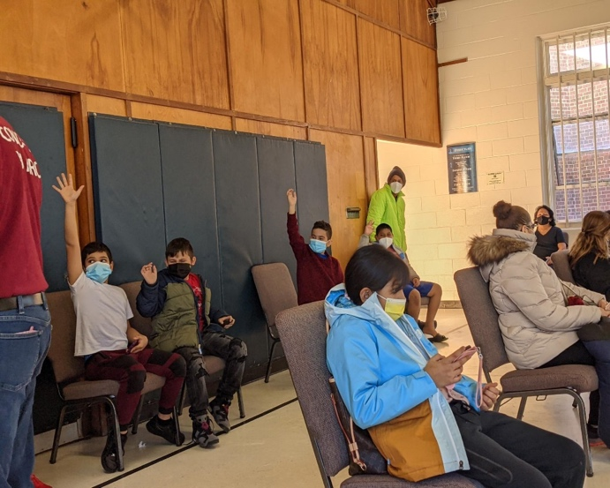

Fall Festival in Culmore

Vaccine Clinic in Springfield

Vaccine Clinic in Springfield

Vaccine Clinic in Springfield

Health Literacy Class in Springfield